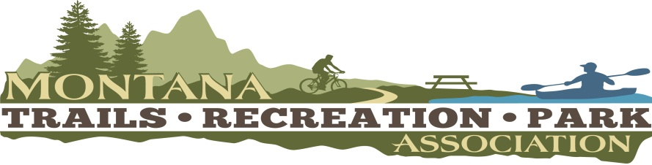
2022 MTRPA Quarterly Board Meeting
Virtual Meeting
Thursday, May 26 @ 3:30p
Zoom Link

3:30 pm Meeting Call to Order Mitch Overton

Item #1 Reading and approval of previous minutes Mitch Overton

Item #2 Secretary/Treasurer Update Chris Waite

Item #3 MTRPA Membership Update Jamie Saitta

Item #4 Website/Communications Update Danielle Beaudin

Item #5 Board Vacancies and Proposed Positions Mitch Overton
- Secretery/Treasurer
- Student Board Member
- Tribal Board Member
- Federal Land Manager Board Member

Item #6 2023 & 2024 Conference Maria Butts

Item #7 2022 Mid Year & Quartlery Meeting Mitch Overton
- MLCT Kalispell, Oct 5-7

Item #8 New Business Mitch Overton
- Conference Debriefing
  - Conference Track by Sub-categories
  - Student track & student presented sessions
- Seasonal Membership Tier
- 501(c)3 Non-Profit Project
- Legislative Session Preparation

Item #8 Adjourn

